Eyespy Core v1 Reference

# Eyespy_Core_v1

**Assembly:** Eyespy Core v1 (in Eyespy Core v1.exe)   
**Namespace**: Eyespy_Core_v1

**Classes**

|  |  |  |
| --- | --- | --- |
|  | **Name** | **Description** |
| Internal (Friend) classSupported by the .NET Compact Framework. | HTTPReader | HTTPReader will be used to extract URL and metadata from a specific HTML dump. |
| Internal (Friend) classSupported by the .NET Compact Framework. | HTTPWriter | Used to interact with Eyespy HQ, through this class are submitted URL's and metadata to the HQ datacenter. |
| Public classSupported by the .NET Compact Framework. | Stack | This stack data structure is used to create a stack frame of size x within which each current-context URL is stored. This class will be dynamically-instantiated by the Systray class. |
| Public classSupported by the .NET Compact Framework. | Systray | Systray class - extends Form class (C# API for GUI building) This is required as System tray programs fall under the Windows Form Application application-type. The Systray class is the main program class for Eyespy Core, it will initialize the components of the GUI, such as the System tray icon. It also catches the incoming stream of HTTP trafic. |
|  |  |  |

Windows 8, Windows Server 2012, Windows 7, Windows Vista SP1 or later, Windows XP SP3, Windows XP SP2 x64 Edition, Windows Server 2008 (Server Core not supported), Windows Server 2008 R2 (Server Core supported with SP1 or later), Windows Server 2003 SP2. The .NET Framework does not support all versions of every platform. For a list of the supported versions, see System Requirements.

#### .NET Framework

Supported in: 4.5, 4, 3.5, 3.0, 2.0, 1.1, 1.0

#### .NET Compact Framework

Supported in: 3.5, 2.0, 1.0

#### XNA Framework

Supported in: 3.0, 2.0, 1.0

**HTTPReader Members**

HTTPReader will be used to extract URL and metadata from a specific HTML dump.

The following tables list the members exposed by the HTTPReader type.

**Methods**

|  |  |  |
| --- | --- | --- |
|  | **Name** | **Description** |
| Public methodSupported by the .NET Compact Framework. | getBetween | Used by the getURL function, this is the underlying algorithm which extracts data between two strings within a source text. |
| Public methodSupported by the .NET Compact Framework. | getMetadata | Get the metadata-keywords from the provided URL. |
| Public methodSupported by the .NET Compact Framework. | getURL | Algorithm as pseudocoded within the Design document. This function will extract the URL from the HTML data. |

# 

# HTTPReader.getBetween Method

Used by the getURL function, this is the underlying algorithm which extracts data between two strings within a source text.   
**Namespace:** Eyespy_Core_v1   
Syntax

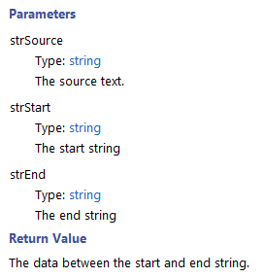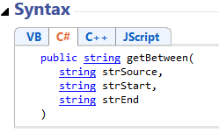

**HTTPReader.getMetadata Method**

Get the metadata-keywords from the provided URL.

**Namespace:** Eyespy_Core_v1   
**Assembly:** Eyespy Core v1 (in Eyespy Core v1.exe)

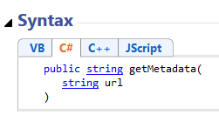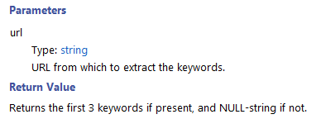

**HTTPReader.getURL Method**

Algorithm as pseudocoded within the Design document. This function will extract the URL from the HTML data.

**Namespace:** Eyespy_Core_v1   
**Assembly:** Eyespy Core v1 (in Eyespy Core v1.exe)

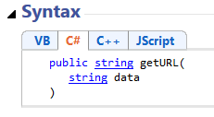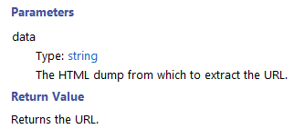

**HTTPWriter Members**

Used to interact with Eyespy HQ, through this class are submitted URL's and metadata to the HQ datacenter.

The following tables list the members exposed by the HTTPWriter type.

**Methods**

|  |  |  |
| --- | --- | --- |
|  | **Name** | **Description** |
| Public methodSupported by the .NET Compact Framework. | submitToHQ | Once the URL has passed all the validation stages, it can be posted to the HQ via this procedure. |

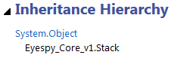

**HTTPWriter.submitToHQ Method**

Once the URL has passed all the validation stages, it can be posted to the HQ via this procedure.

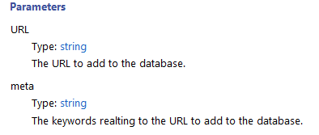**Namespace:** Eyespy_Core_v1   
**Assembly:** Eyespy Core v1 (in Eyespy Core v1.exe)

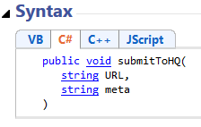

**Stack Class**

This stack data structure is used to create a stack frame of size x within which each current-context URL is stored. This class will be dynamically-instantiated by the Systray class.

**Namespace:** Eyespy_Core_v1   
**Assembly:** Eyespy Core v1 (in Eyespy Core v1.exe)

The following tables list the members exposed by the Stack type.

**Constructors**

|  |  |  |
| --- | --- | --- |
|  | **Name** | **Description** |
| Public constructorSupported by the .NET Compact Framework. | Stack Constructor | Initialize main components of the stack |

**[Methods](javascript:void(0)" \o "Collapse)**

|  |  |  |
| --- | --- | --- |
|  | **Name** | **Description** |
| Public methodSupported by the .NET Compact Framework. | isMemorized | Check if a URL is defined within the current stack frame. |
| Public methodSupported by the .NET Compact Framework. | push | Add a new item to the stack frame and ensure the stack is not in overflow (and reset it if it's the case). |

**Fields**

|  |  |  |
| --- | --- | --- |
|  | **Name** | **Description** |
| Public fieldSupported by the .NET Compact Framework. | stackFrameCount | Number of times has the stack reached its maximum size and been reset - used for the 'About' context-menu item. |
| Private fieldSupported by the .NET Compact Framework. | stackItems | Each member of this array is a URL corresponding to an item of the stack, where the index is the address. |
| Private fieldSupported by the .NET Compact Framework. | stackPointer | Like in a real-world stack, a stack pointed variable is required. this integer hold the index of the last added item. (LIFO principle) |
| Private fieldSupported by the .NET Compact Framework. | stackSize | Maximum size of the stack before it needs resetting. this variable is assigned in the constructor by the 'size' parameter. |



**Stack.isMemorized Method**

Check if a URL is defined within the current stack frame.

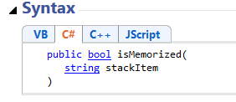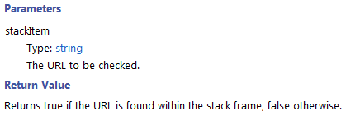**Namespace:** Eyespy_Core_v1   
**Assembly:** Eyespy Core v1 (in Eyespy Core v1.exe)

**Stack.push Method**

Add a new item to the stack frame and ensure the stack is not in overflow (and reset it if it's the case).

**Namespace:** Eyespy_Core_v1   
**Assembly:** Eyespy Core v1 (in Eyespy Core v1.exe)

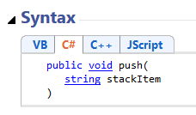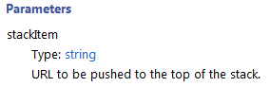

**Systray Class**

Systray class - extends Form class (C# API for GUI building) This is required as System tray programs fall under the Windows Form Application application-type. The Systray class is the main program class for Eyespy Core, it will initialize the components of the GUI, such as the System tray icon. It also catches the incoming stream of HTTP traffic.

**Namespace:** Eyespy_Core_v1   
**Assembly:** Eyespy Core v1 (in Eyespy Core v1.exe)

|  |  |  |
| --- | --- | --- |
|  | **Name** | **Description** |
| Public constructorSupported by the .NET Compact Framework. | Systray Constructor | Constructor for the class - will create the system tray icon. |
|  |  |  |

**Methods**

|  |  |  |
| --- | --- | --- |
|  | **Name** | **Description** |
| Protected methodSupported by the .NET Compact Framework. | About | "About" menu item onload event to display detailed info |
| Protected methodSupported by the .NET Compact Framework. | Dispose | destroy the icon (on exit) |
| Private methodSupported by the .NET Compact Framework. | InitializeComponent | This function in override of the Form GUI class that Systray extends. Into this function are parsed parameters such as the size of the client and the name of the context icon. |
| Private methodStaticSupported by the .NET Compact Framework. | Main | The main entry point for the application. |
| Private methodStaticSupported by the .NET Compact Framework. | OnClientRecieve | OnClientReceive is asynchronously called by the program loop to handle data. Within this function various validations are made to ensure the link is authentic before submitting it to Eyespy HQ via the writer instance. |
| Protected methodSupported by the .NET Compact Framework. | OnLoad | Launched procedure to load the icon |

**Fields**

|  |  |  |
| --- | --- | --- |
|  | **Name** | **Description** |
| Private fieldStaticSupported by the .NET Compact Framework. | bResponceBytes | This byte array serves as a buffer for incoming data. The byte array will later be encoded into a string to extract URL/meta info. |
| Private fieldStaticSupported by the .NET Compact Framework. | blockedURLCount | Number of blocked URL's - this variable can be incremented for various reasons, such as URL size is too big, or the inbound data did not present a GET parameter within its header. |
| Private fieldStaticSupported by the .NET Compact Framework. | reader | Eyespy-defined class - HTTPReader object created to read data from the inbound HTML data. The data that it will extract is: URL and meta-info. |
| Private fieldStaticSupported by the .NET Compact Framework. | repeatURLCount | Number of repeated URL's within the current stack frame. |
| Private fieldStaticSupported by the .NET Compact Framework. | sock | Socket declaration for usage within the program loop - sock will catch all inbound HTTP traffic. |
| Private fieldStaticSupported by the .NET Compact Framework. | stack | Eyespy-defined class - this data structure instance will serve as a stack-frame. The size of the stack frame is defined within the constructor, and is passed as a constructor parameter. Repeated URL's will be found thanks to this class. |
| Private fieldStaticSupported by the .NET Compact Framework. | trayIcon | The NotifyIcon class is responsible for creating the System tray icon, arguments passed to this instance are systray icon related. |
| Private fieldStaticSupported by the .NET Compact Framework. | trayMenu | trayMenu yeilds the tray icon context menu, via this object can be added attributes to the context menu (when you right click on the icon) |
| Private fieldStaticSupported by the .NET Compact Framework. | urlcount | Number of URL’s processed and submitted to the HQ datacentre. |
| Private fieldStaticSupported by the .NET Compact Framework. | writer | Eyespy-defined class - HTTPWriter is used to write data to the Eyespy HQ. |

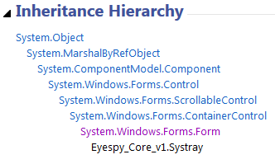

**Systray.About Method**

"About" menu item onload event to display detailed info

**Namespace:** Eyespy_Core_v1   
**Assembly:** Eyespy Core v1 (in Eyespy Core v1.exe)

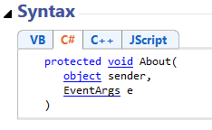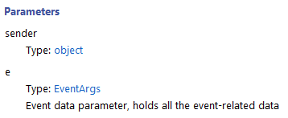

**Systray.Dispose Method**

Destroy the system tray icon (on exit)

**Namespace:** Eyespy_Core_v1   
**Assembly:** Eyespy Core v1 (in Eyespy Core v1.exe)

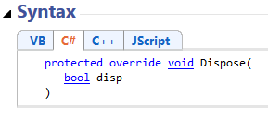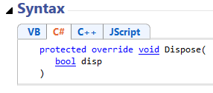

**Systray.InitializeComponent Method**

This function in override of the Form GUI class that Systray extends. Into this function are parsed parameters such as the size of the client and the name of the context icon.

**Namespace:** Eyespy_Core_v1   
**Assembly:** Eyespy Core v1 (in Eyespy Core v1.exe)

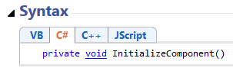

**Systray.Main Method**

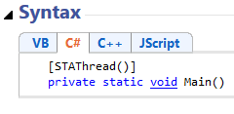The main entry point for the application.

**Namespace:** Eyespy_Core_v1   
**Assembly:** Eyespy Core v1 (in Eyespy Core v1.exe)

**Systray.OnClientRecieve Method**

OnClientReceive is asynchronously called by the program loop to handle data. Within this function various validations are made to ensure the link is authentic before submitting it to Eyespy HQ via the writer instance.

**Namespace:** Eyespy_Core_v1   
**Assembly:** Eyespy Core v1 (in Eyespy Core v1.exe)

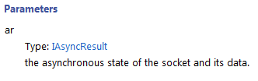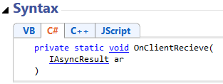

**Systray.OnLoad Method**

Launched procedure to load the icon

**Namespace:** Eyespy_Core_v1   
**Assembly:** Eyespy Core v1 (in Eyespy Core v1.exe)

